**AIM:**  Design DFA using simulator to accept the string having ‘abc’ as substring over the set {a,b,c}

**INPUT:**

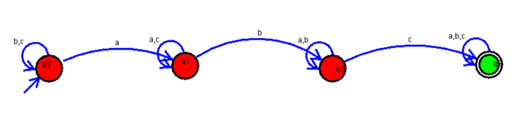

**OUTPUT:**

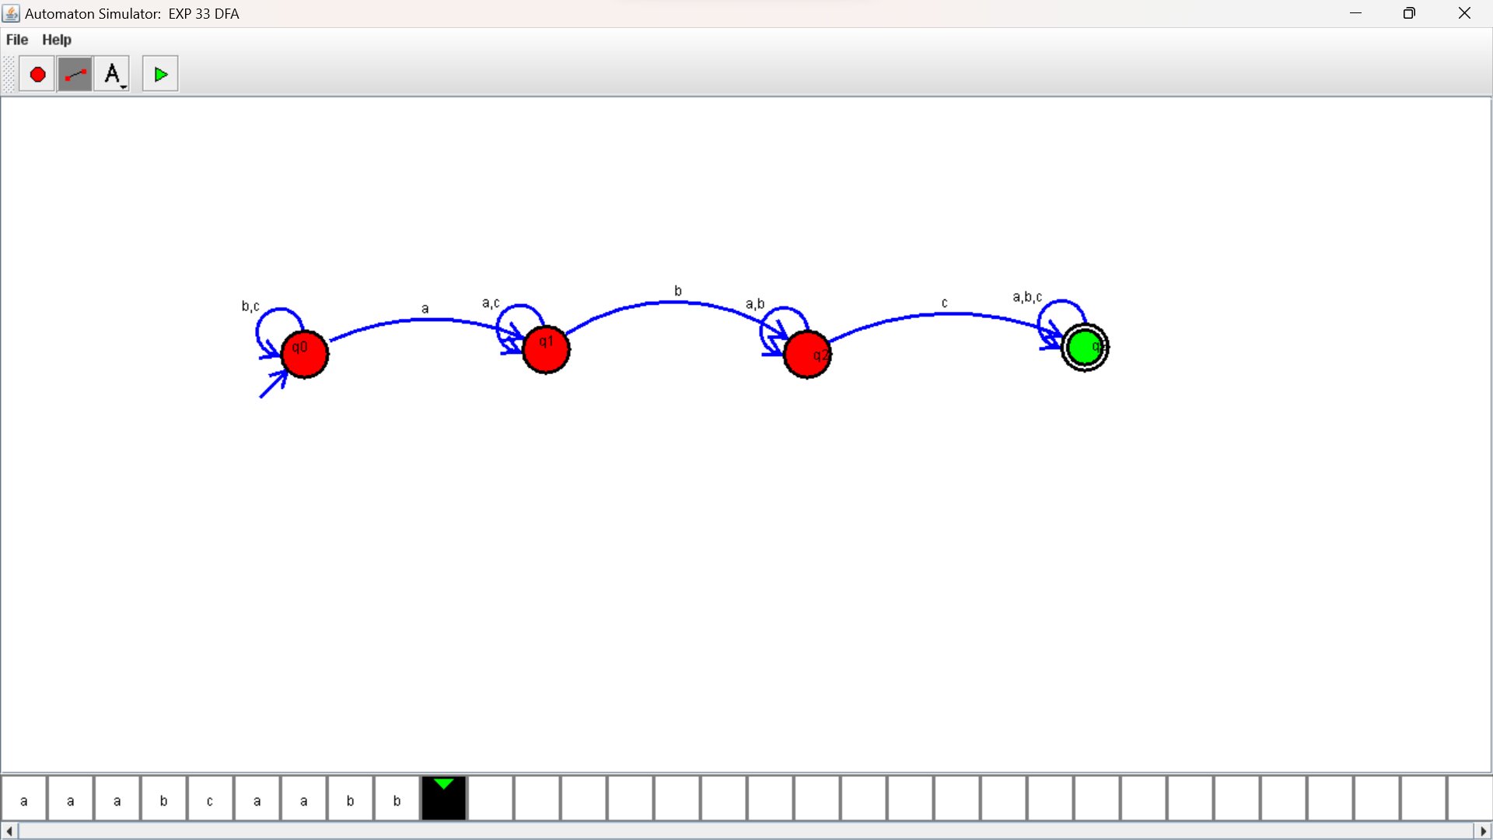

**RESULTS:**

DFA using simulator to accept the string having ‘abc’ as substring over the set {a,b,c}